**Netflux Documentation**

(v.1.0)

**Overview**

Netflux is a signaling pathway/network analysis tool that does not require any parameter data (such as time constants or species concentrations). Netflux simply requires knowledge of whether species “A” activates or inhibits species “B”, and by how much. A user generated Network Excel spreadsheet defines all of the species and reaction rules, and the spreadsheet is used as input for Netflux. Running Netflux will create a graphical user interface (GUI) that allows the user to define and run simulations and graph species fractional activation as a function of time, which can then be used for different analyses, such as identifying important nodes of a network.

**Contents**

1. **Installation**
2. **Getting Started**
3. **Overview of the Netflux Graphical User Interface**
4. **Formatting the Excel Network File**
5. **Visualizing the Network with Cytoscape**
6. **Using Dynamic Expression to Visualize Signal Propagation**
7. **Creating a Movie using CamStudio**
8. **Using the SBML-QUAL and SIF Conversion Tool****s**

**I. Installation**

1. FirstDownload the Netflux program from GitHub (link can be found at: <https://github.com/saucermanlab/Netflux>) by clicking on the button labeled “Download ZIP.” The contents of this zip file are:
   1. Netflux Compiled
   2. Netflux
   3. Models
   4. License.txt

**There are two installation procedures:**

* **IA is for MATLAB Independent (Users without MATLAB)**
* **IB is for MATLAB Dependent (Users with MATLAB)**

**IA. Installing Netflux for MATLAB Independent Users (Users without MATLAB)**

1. Open the “Netflux Compiled” folder. The contents of this zip file are:
   1. Documentation
   2. 3 example Netflux Excel models.
   3. license.txt – license for the program
   4. Netflux SBGN.props– visual property file for Cytoscape
   5. *Netflux installer.exe* – the main Netflux program
   6. dynamicXpr.jar – A Cytoscape plugin that is required to visualize signal propagation in Cytoscape.
2. Double click Netflux Installer.exe to install and run the program.

**IB. Installing Netflux for MATLAB Dependent (Users with MATLAB)**

Note: MATLAB must be version 2009b or higher

1. Move the “Netflux” folder containing the source code into your desired directory. The contents of this zip file are:
   1. Documentation
   2. exampleNet.xlsx – An example Network Excel File
   3. license.txt – license for the program
   4. *Netflux SBGN.props ­*– visual property file for Cytoscape
   5. Netflux.m – The main *Netflux* program
   6. +util – .m files needed for *Netflux* to run
   7. +gui - .m files needed for the *Netflux* GUI
   8. utilities- .m and .fig files needed to run the model conversion and export dialogues (coded with GUIDE).
   9. Path2Models – A folder containing autogenerated Netflux models from the Path2Models database.
   10. dynamicXpr.jar – A Cytoscape plugin that is required to visualize signal propagation in Cytoscape.

**II. Getting Started with *Netflux***

1. Double click *Netflux.exe* or run *Netflux.m* (depending on which version you downloaded) to start Netflux.
   1. Note: On some machines, it may take a couple minutes for the prompt to appear. Be patient and do not double click *Netflux.exe* more than once.
2. In the File menu, select Open Model. A dialog box will prompt you for an Excel file that contains your network; input your network Excel file (or *exampleNet.xlsx* if you do not have one).
3. The Status Text will indicate that your file was loaded successfully.
4. Press the “Simulate!” button. Congratulations, you have run your first simulation! More details about the function of each button and the various parameters are detailed below.

**III.** **Overview of the Netflux Graphical User Interface**

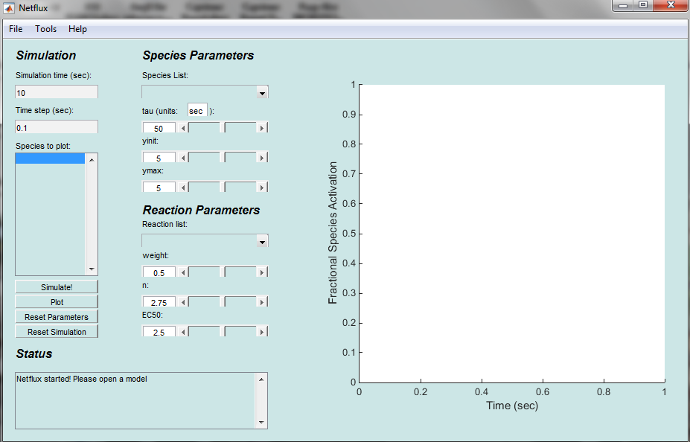

**FIGURE 1. A screenshot of the Netflux GUI.**

1. ***Simulation Time*** – Input the time (in seconds) that you want to simulate your reaction. The time starts from the last time point in your previous simulation. For example, if you simulated the reaction for 10 seconds previously, and Simulated again for 10 seconds, the Graph and Data will show for 20 seconds. “Reset Simulation” in order to start from time zero.
2. ***Time Step***—The time interval between plotted solution points.
3. ***Species to Plot*** – The species highlighted will be the species plotted in the graph. Control+click in order to plot multiple species at once. The plotting occurs after you push “Simulate!”
4. ***Simulate***! – Causes the simulation to occur.
5. ***Plot*** – Replot the graph without running through another simulation. For example, you forgot to plot Species B with Species A and you do not want to go through another simulation.
6. ***Reset Parameters*** – Resets all species and reaction parameters.
7. ***Reset Simulation*** – Resets the starting time to zero and clears the graph. Does **NOT** reset the parameters.
8. ***Status Text*** – Displays various messages depending on your actions.
9. ***Species List***  - A drop down menu for you to select which species to alter.
10. ***Tau*** – A slider bar for you to alter the reaction time constant parameter of your selected species.
11. ***Tau Unit Definition –*** A text denoting the units of time for the time constant, which determines the time step, simulation time, and time axes label. Press enter to change the units.
    * *Note*: The units of the time constant determine the units of time in the simulation, but have no effect on the simulations or the solutions because the units are arbitrary.
12. ***Yinit*** – A slider bar for you to alter the initial y parameter of your selected species.
13. ***Ymax*** – A slider bar for you to alter the ‘ymax’ parameter of your selected species.
14. ***Reaction List*** – A drop down menu for you to select which reaction to alter.
15. ***Weight*** – A slider bar for you to alter the reaction weight parameter of your selected reaction.
16. ***n*** – A slider bar for you to alter the hill coefficient parameter of your selected reaction.
17. ***EC50*** – A slider bar for you to alter the half-maximal effective concentration parameter of your selected reaction.

File Menu

1. 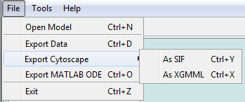***Open Model*** – Loads an Excel file. Doing so will reset all parameters and graphs.
2. ***Export Data*** – Exports the data for each species at intervals defined in the "Time-Step" field into a text file for use in programs such as Cytoscape (<http://www.cytoscape.org/>).
   * Note: the data are space delimited.
3. ***Export Cytoscape*** 
   * As SIF—Exports the network into yournetworkmodel.sif and yournetworkmodel_nodeAttributes.txt for use in Cytoscape.
   * As XGMML—Exports the network into an XGMML file for use in Cytoscape.
4. ***Export ODE*** – Exports a MATLAB-ready M-file.

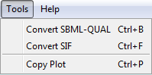

Tools Menu

1. ***Convert SBML-QUAL-***Converts an SBML-QUAL file into a Netflux Excel model and SIF/Node Attributes file.
2. ***Convert SIF***-Converts a SIF file to a Netflux Excel model.
3. ***Copy Plot***-Copies the current plot in a separate window.

C:\Users\Stephen\Real Documents\School Work\Lab\NetfluxWikiPics\Poster Pics\Netflux help men.bmp

Help Menu

1. ***About Netflux*** – Displays the About window.

**IV.** **Formatting the Excel network file**

Netflux requires an Excel network file of a certain format. Information is stored in two Excel sheets, ‘reactions’ and ‘species’. To create new networks, it is advised to open ‘exampleNet.xlsx’, save it to a new filename, and then modify the network appropriately. It is advised that Excel spreadsheets are saved as .xlsx file because occasional incompatibilities have been found with older Excel file formats such as .xls. This will ensure that the correct formatting is used and Netflux will be able to read the file correctly. Note that Netflux does not currently have extensive error handling, and incorrect formatting is likely to crash the program; see the end of the page for solutions to common errors.

Some things to keep in mind:

* Data has to start on line 3.
* The preferred file type for Neflux is .xlsx. Some occasional incompatibilities have been found with older Excel file formats such as .xls with the built in MATLAB function xlsread.m. If you are encountering errors with models saved as an .xls file try saving it as an .xlsx file and try again. Files saved as 97-2003 Excel Workbook may or may not read correctly.
* Network names (i.e., the Excel file name) cannot have spaces; use underscores instead.

**Reactions Sheet**

The ‘reactions’ sheet stores the reaction rules, reaction parameters and other reaction-specific information. An example is shown in Figure 2. **Reaction ID’s are stored in column B, reaction rules in column C, reaction weights in column D, hill coefficients in column E, and half-maximal effective concentration in column F. Make sure to name this sheet “reactions”.**

*Reaction ID’s*- this should be a unique name for the reaction with **no spaces or special symbols**

*Reaction Rules*-

1. Input reactions: For an input that activates species ‘A’, use ‘ ‘=> A’.

**Note: Be sure to include an apostrophe before the equals sign, e.g.,** ‘=>**A**

2. Simple activation: If species ‘A’ activates species ‘B’, use ‘A => B’.

3. Simple inhibition: If species ‘A’ inhibits or blocks species ‘B’, use ‘!A => B’.

4. Combinations: If species ‘A’ and ‘B’ are both needed to activate ‘C’, use ‘A & B => C’.

5. Combinations: If species ‘A’ does not inhibit but ‘B’ inhibits ‘C’, use ‘A & !B => C’.

6. Self-activation: If species ‘A’ activates itself, use ‘A => A’.

7. Self-inhibition: If species ‘A’ inhibits itself, use ‘!A => A’.

*Weight* – this is a number between 0 and 1 specifying the maximal activity for that pathway. This is normally set at 1. If you would like to fully inhibit a reaction, set the weight to 0. For input reactions (e.g. => I1), this determines the activity of that input (1 for fully activated, 0 for not activated).

*n* – this number is the hill coefficient, which characterizes ligand interactions. The default value for this parameter is 1.4.

*EC50* – this number is the half-maximal effective concentration, which determines at what fraction of the input species would induce half-maximal activation of an output species. The default value for this

parameter is 0.5.

*Notes* – anything to the right of the EC50 column can be used for notes, they are not read by the Netflux program.

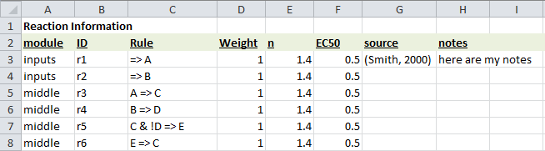

**FIGURE 2. The ‘reactions’ sheet from ‘exampleNet.xlsx’.**

**Species Sheet**

The ‘species’ sheet defines the list of ‘species’ to be included in the model, along with associated information. An example is shown in figure 3. **The species ID is stored in column B, species name in column C, Ymax in column D, and the time constant in column E.** **Make sure to name this sheet “species”.**

*Species ID* – Column B is a short unique name for that species that does not contain any spaces. More specifically, ‘ID’ should be an allowable variable name in MATLAB (most users do not have to worry about conflicting naming conventions).

*Species Name* *–* Column C is the ‘name’ field, which is used for the name of the species. This column is currently read but has no use in Netflux; treat it as a note for yourself.

*Yinit* – The initial conditions for your species. The default value is 0.

*Ymax* – The species maximal fractional activation. The default value is 1, but can be changed to reflect changes in protein expression relative to a reference condition1.

*Tau* – The reaction time constant. The default value is 1.

*Type* – This column defines the node type in the SBGN Process Description format for node formatting in Cytoscape. The SBGN node types and corresponding shapes are shown in Figure 3.

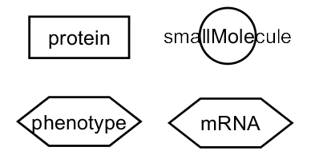

**FIGURE 3**: **Cytoscape node shapes corresponding to the available values in the Type column of the Excel spreadsheet.**

*Notes* – Anything columns to the right of the “type” column can be used for notes, they are not read by Netflux.

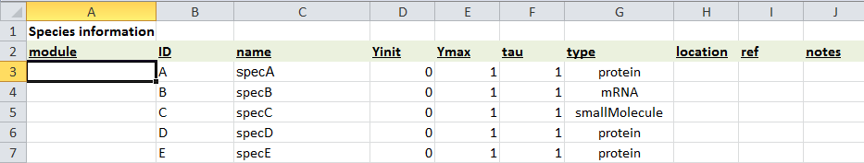

**FIGURE 4**: **The ‘species’ sheet from ‘exampleNet.xlsx’.**

Solutions to Common Errors

* Be sure to use the species IDs and not the species names when writing the reaction rules.
* ‘species’ and ‘reactions’ tabs have to be this exact spelling and case.
* Cannot have both regular and bold font in a cell
* UNICODE characters cannot be read
* For Input Species, make sure to input ‘=>A, not just =>A (as this would prompt a function).
* Make sure there are no plots in the sheets.
* For Google Doc Users: After exporting as an Excel file, open up the Worksheet, and re-save it as a .xlsx file using another spreadsheet program, such as Microsoft Excel or OpenOffice.
  + Reason: Exporting from Google seems to save the data into Unicode, which Netflux does not support. Saving the file again using another spreadsheet program will remedy this error.
* For OpenOffice Users: Save as an .xlsx file types
* If the model does not load, try copying and pasting the data from each sheet into a new .xlsx file and resaving. If that doesn't work, try saving as .xls instead of .xlsx.

**V. Visualizing the Network with Cytoscape**

Cytoscape is a free program that can be used to visualize your network as a set of Nodes (species) and edges (reactions). Netflux can export models in two Cytoscape File formats: SIF and XGMML. XGMML is capable of storing the locations, attributes, and vizmap properties and reaction logic in a single file. SIF files only contain information about the reaction logic, so the visual style and other attributes must be saved in separate files or manually set each time a SIF file is loaded into Cytoscape.

There are 3 ways to export a model to Cytoscape

1. **Exporting a model as a SIF file.**
2. **Exporting a model as an XGMML with default visual layout.**
3. **Exporting a model with retained formatting from a previous Cytoscape export.**
4. **Exporting a Model as a SIF file:**

SIF is the most basic Cytoscape file type. It only contains information about the species (nodes) and activating or inhibiting reactions between them (edges). Once this file is loaded into Cytoscape, the appearance and layout of the nodes are rearranged manually with the use of node attribute and VizMapper property files that are also exported using this option.

1. Load a model into Netflux by going to:

File🡪Open Model

1. Then, in Netflux go to:

Select File🡪Export Cytoscape🡪As SIF

In this step, Netflux exports a SIF file (.sif) and a node attributes (.txt) file, both will be imported in Cytoscape.

1. To import the SIF file open Cytoscape and go to:

File 🡪 Import 🡪 Network (Multiple File Types)...

1. Select the SIF file that you exported from Netflux in step 2.
2. Then, import the node attributes file by going to:

File 🡪 Import 🡪 Node Attributes

1. If desired, load the "Netflux SBGN.props" file by going to:

File 🡪 Import 🡪 Vizmap Property File…

1. Then, in the vizmapper Control Panel pulldown menu set "Current Visual Style" to "Netflux SBGN" (Shown Below)

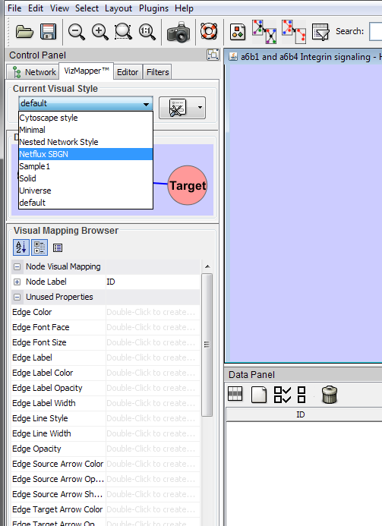

1. **Exporting a Model as an XGMML with default visual layout**

XGMML files hold the information from the files exported in a SIF export (SIF, and Node/Edge attribute files), except they are in a single .xgmml file. XGMML files also automatically apply the SBGN visual format, so the VizMapper property file import in Cytoscape is not required.

1. Load a model into Netflux by going to:

File🡪Open Model

1. Select File🡪Export Cytoscape🡪As XGMML. The following dialogue will be shown:

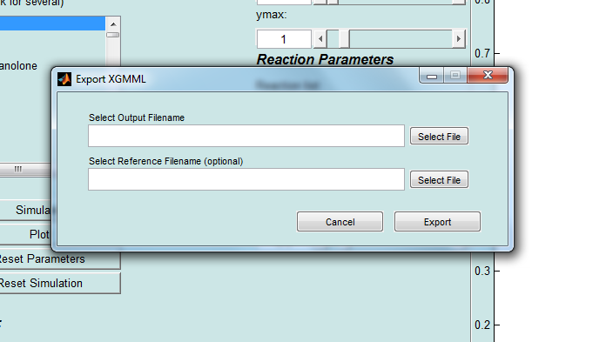

1. There are two fields in the dialogue box. In this example, we will leave the Reference Filename field blank, which will export the network with the default visual style.
2. Click "Select File" next to the "Select Output Filename" field to define the name and location of the XGMML file that will be exported.
3. Click "Export"
4. In Cytoscape and go to

File 🡪 Import 🡪 Network (Multiple File Types)...

1. Select the .xgmml file that you exported from Netflux in step 4.
2. You will also need to select the Hierarchic layout for the network. To do so, in Cytoscape go to

Layout 🡪 yFiles 🡪 Hierarchic

Your network will now look as it is below (with some manual modification)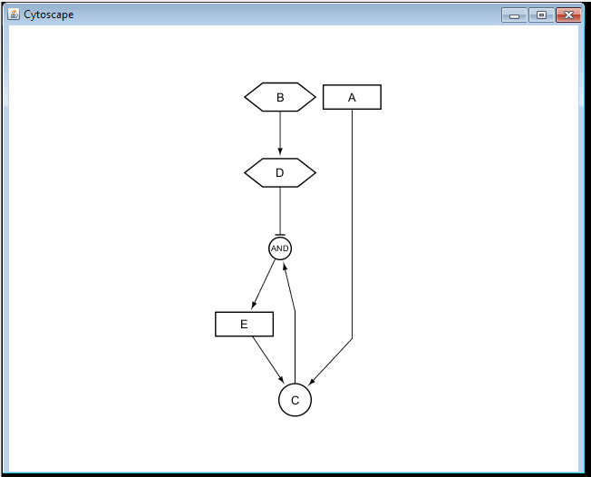

1. **Exporting a Model as an XGMML with retained formatting from a previous Cytoscape export**

We created a tool in Netflux to retain the formatting of all reused nodes from a previous Cytoscape session using Cytoscape's ability to export files as XGMML. This makes it possible to build network maps in a stepwise manner without having to rearrange all of the nodes every time you add a reaction to the Excel sheet. In this example we will add the reaction A => D to exampleNet.xlsx, and export it from Netflux as an XGMML file. During the export, we will reference an existing Cytoscape session that has a map of the original exampleNet.xlsx, and the existing node positions from that file will be retained in the new export.

1. From the Cytoscape session you want to reference export the model as an XGMML so it can be referenced by Netflux (example filename: "exampleCytoscapeExp.xgmml") (Shown below):

File🡪Export🡪Network and Attributes as XGMML…

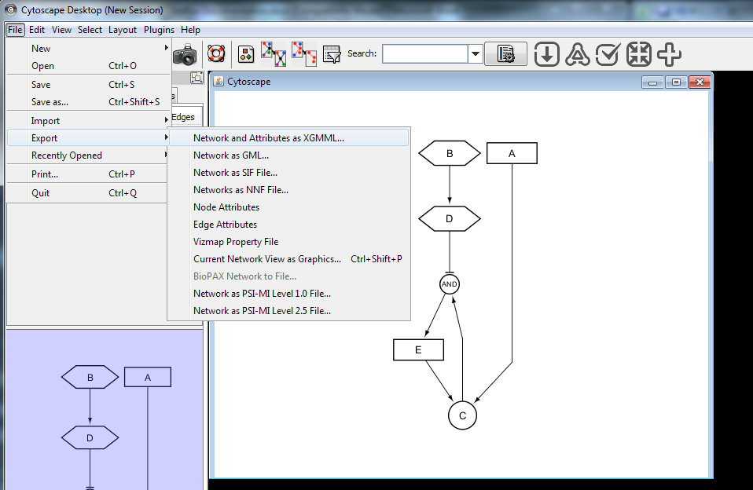

1. In this example, we will add a reaction (r7) to the model Excel spreadsheet (Shown Below)

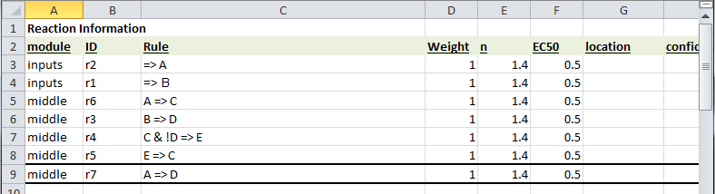

1. Open the Excel model in Netflux
2. In Netflux select

File🡪Export Cytoscape🡪 As XGMML

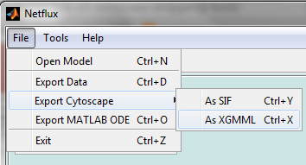

1. Select the output filename, for example: "exampleNetfluxExp.xgmml"
2. In the “reference .xgmml” field Select the XGMML that was exported from Cytoscape in step 1.
   1. Note: the reference XGMML must be exported from Cytoscape 2.8.3.
3. Click Export.
4. Open the XGMML exported from Netflux in Cytoscape.
5. The model should add the reaction with node positions retained from previous export (As shown below).

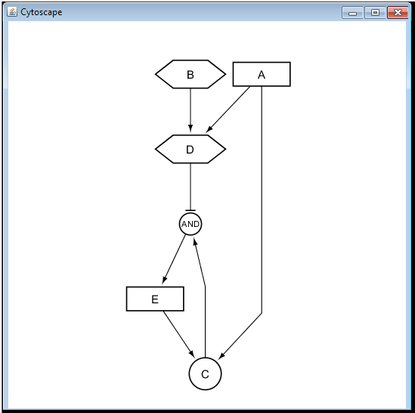

**VI. Using Dynamic Expression to Visualize Signal Propagation**

The Dynamic Expression plugin for Cytoscape can be used to view how a signal propagates in your network. You will need to use the Netflux GUI to export the Cytoscape and data sheet files.

1. To install the Dynamic Expression plugin on Cytoscape 2.8.3 drag and drop the “dynamicXpr.jar” file into the “plugins” folder in the Cytoscape program files. The default location for this folder is C:\Program Files\Cytoscape_v2.8.3\plugins.
2. Next, in Cytoscape open “Manage Plugins”

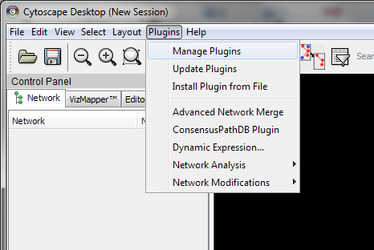

1. Select "Dynamic Expression" in “Analysis” folder and install dynamicXpr v1.3. Despite the warning, dynamicXpr v1.3 works with Cytoscape 2.8.3.

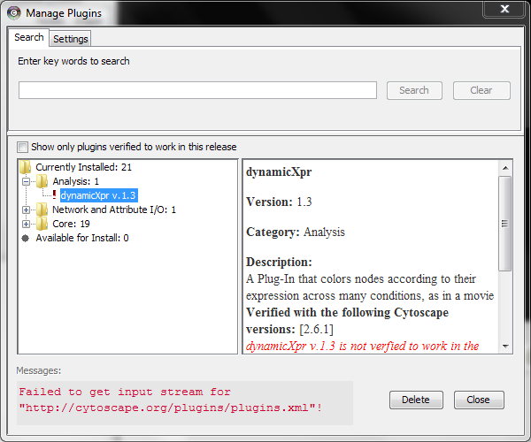

1. If you haven't already, export your model as an XGMML or SIF file and load into Cytoscape as described in Section V.
2. Run the simulation conditions you would like to visualize in the Netflux GUI. Select an appropriate time step. We have found that ~0.1-0.5 seconds for visualization with Dynamic Expression works well.
3. Select File🡪Export Data from the Netflux GUI to save the species activations as a text file in the desired location.
4. Open Cytoscape and Import the Netflux "Netflux SBGN.props" property file using File🡪Import🡪 Vizmap Property File.
5. Then, make sure “Netflux SBGN” is selected as the current visual style.



1. Open the Dynamic expression plugin from Cytoscape by going to

Plugins🡪 Dynamic Expression

1. In the Dynamic Expression window, select the data sheet you exported from Netflux in Step 4.
2. Press play. The nodes should start changing colors according to their activation. The default scale is shown below with an example at one time point:

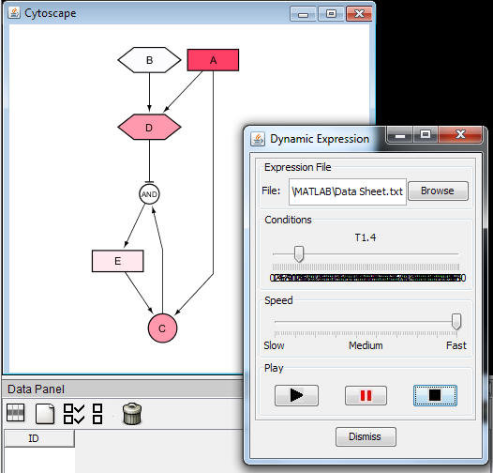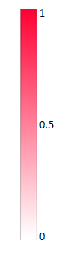

**VII. Creating a Movie Using CamStudio**

1. Download CamStudio at the following link: <http://camstudio.org/>.
2. Open *Camstudio Recorder* found in the CamStudio folder. You will also need to generate a Cytoscape network using Dynamic Expression (Section IV), but do not play the Dynamic Expression yet.
3. Arrange Dynamic Expression and CamStudio in Cytoscape like Figure 12:

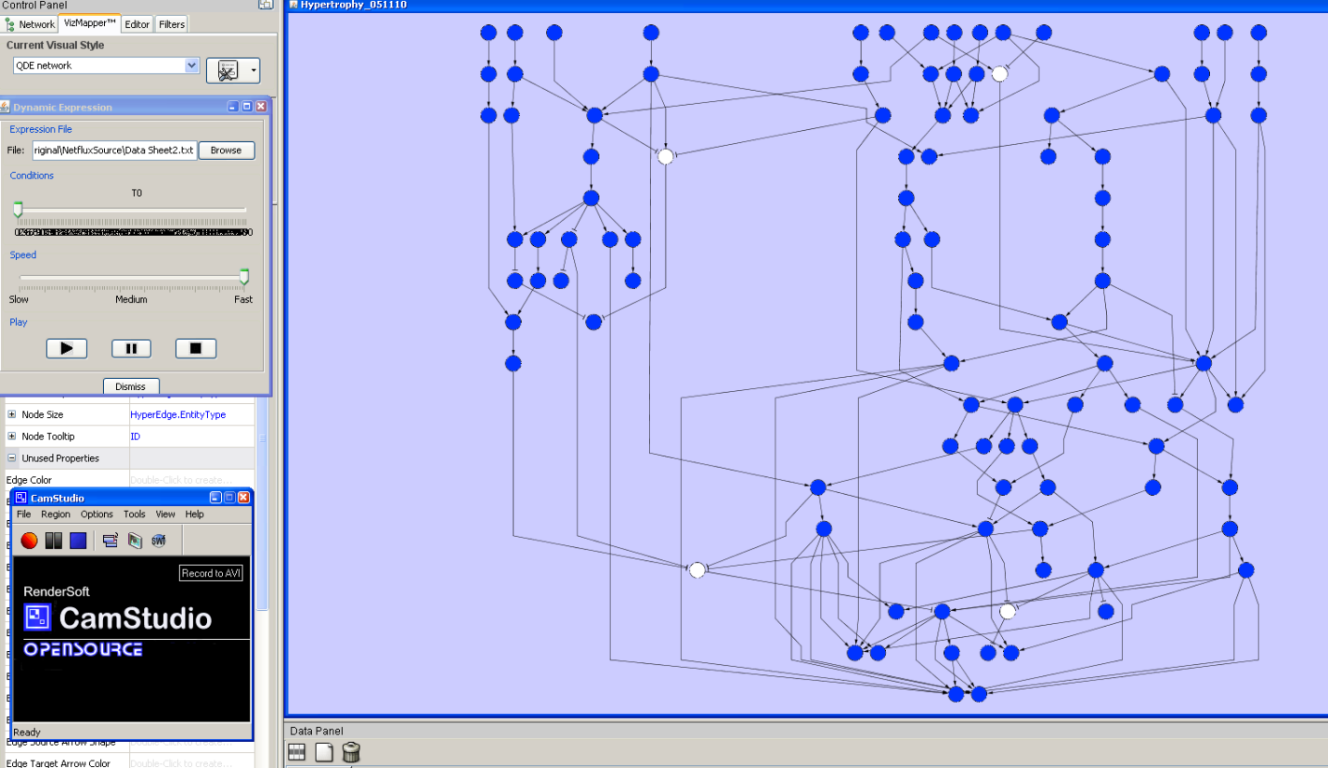

**FIGURE 12. Dynamic Expression (red) and Camstudio (green) on the Cytoscape screen. The region you want to capture is boxed in Purple.**

1. In the CamStudio Window, select the region for recording by selecting

Region 🡪 Fixed Region…

Then in the Fixed Region window, click on Select. A pen symbol will appear. Use the pen to select the region you want to record (Figure 12, purple box), then click ‘Ok’.

1. Before recording, you will need to adjust the video options of CamStudio. To do so, go to

Options 🡪Video Options

On the Video Options window, click on Configure, then adjust the Temporal Quality Ratio to 0.7. Exit out of the Configure window, uncheck the Auto Adjust check box, then adjust the settings according to Figure 13. These settings provide the best default image quality while maintaining a small data file size. Advanced users may modify these settings to their liking.

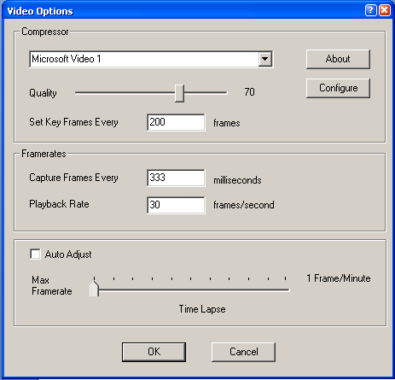

**FIGURE 13. Settings for optimal image capture in CamStudio.**

Click OK to finish adjusting.

fig7.bmp

1. In the CamStudio Window, click to begin recording. Then, press the Play button in the Dynamic Expression window to play the video.
2. Press fig8.bmp to stop recording and save the file to your desired output folder.

**VIII. Using the SBML-QUAL and SIF Conversion Tools**

The SBML-QUAL conversion tool is compatible with non-metabolic models from the Path2Models Database. This tool converts the SBML-QUAL file into a Netflux excel model, which can be simulated and exported to Cytoscape using the Netflux GUI. A .sif file is also autogenerated from the conversion for direct visualization in Cytoscape.

1. Download an SBML-QUAL file from the non-metabolic section of the Path2Models Database: <http://www.ebi.ac.uk/biomodels-main/path2models?cat=non-metabolic>
2. Select

**Tools🡪 Convert SBML-QUAL**

**Or**

**Tools🡪 Convert SIF**

1. Select the SBML-QUAL or SIF file from step 1 and specify an output folder:
2. Click Convert.
3. The Netflux Excel model will be exported to the location you specified in step 3.